
Amazon Interview Worksheet
BIAS FOR ACTION
Definition and Indicators
Bias for Action: Speed matters in business. Many decisions and actions are reversible and do not need extensive study. We value calculated risk taking.
What this looks like in Practice
As a people manager do you… | As an individual contributor do you…
- Makes sound, timely decisions and remove barriers for direct reports?  - Quickly identify how work should be done and communicated to team?  - Make timely, sound decisions for the business even when all info you want to have isn’t available?  - Empower your employees or become a bottleneck?  - Remove barriers to help your team act on new ideas immediately? | - Quickly identify if you need more info before taking action request that info and move forward?  - Be ready, willing and able to roll up sleeves and assist with customer facing tasks when needed?  - Ask for help when needed in a timely manner?  - Respond promptly to requests for information?  - Follow up and deliver as promised?  - Make sure you create an “action item list” (identify owner and target dates)?

Bias for Action - Suggested Behavioral Interview Questions
For each question you choose, use a separate STAR Worksheet
Questions for (Manager) in parentheses

- Give me an example of a calculated risk that you have taken where speed was critical. What was the situation and how did you handle it? What steps did you take to mitigate the risk? What was the outcome?
- Describe a situation where you made an important business decision without consulting your manager. What was the situation and how did it turn out?
- Tell me about a time when you had to analyze facts quickly, define key issues, and respond immediately to a situation. What was the outcome?
- Tell me about a time when you have worked against tight deadlines and didn't have the time to consider all options before making a decision. How much time did you have? What approach did you take?
- Give an example of when you had to make an important decision and had to decide between moving forward or gathering more information. What did you do? What information is necessary for you to have before acting?
- Tell me about a time where you felt your team was not moving to action quickly enough. What did you do? (Manager)
- Tell me about a time when you were able to remove a serious roadblock/barrier preventing your team from making progress? How were you able to remove the barrier? What was the outcome? (Manager)

STAR WORKSHEET
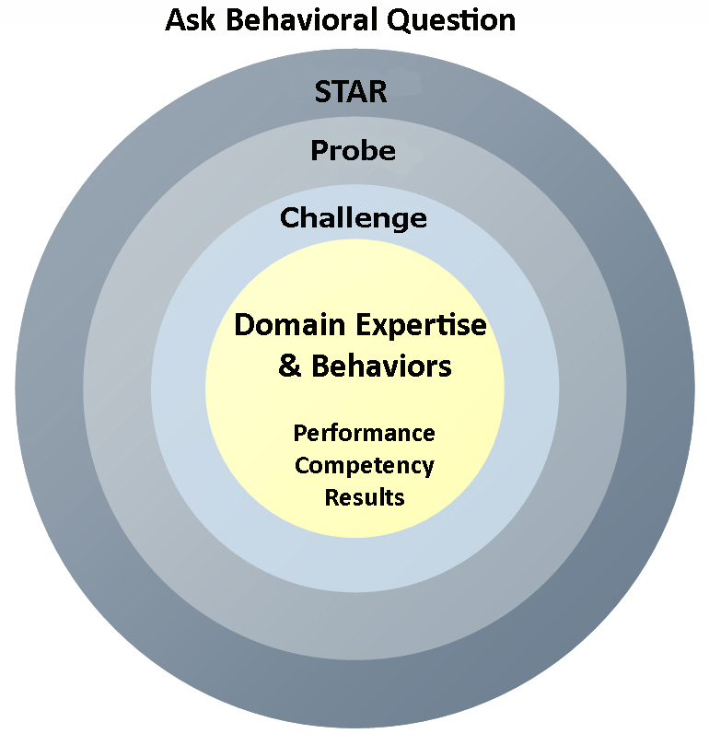
Your Behavioral Question:___________________________________________________________________Leadership Principle:_________________

- Choose behavioral question that provoke specific examples or stories for your assigned Leadership Principle(s).
- Process the example using STAR. Stories have beginnings (Situation/Task), middles (Actions) and ends (Results).
- Once you have established the story, PROBE to dive deeper on your assigned competency (Leadership Principle), get clarity or pursue a concern.
- If appropriate, CHALLENGE the candidate’s statements, decisions or thought process.
S  T | SITUATION/TASK - Describe the situation/task you faced and the context of the story  Answers the questions: where did this occur, when did it happen, why is it important?  Probing Questions:  - Why is this important? What was the goal?  - What was the initial scope of the project? What were the challenges?  - What were the risks and potential consequences if nothing happened?  Challenge Questions:  - Why did you choose this story to illustrate a xyz accomplishment?  - What other stories can you think of that demonstrate.. xyz?  - Could you come up with an example that is more recent? | Notes
A | ACTION - What actions did you take?  Answers the questions: what did you personally own, how did you do it, who else was involved?  Probing Questions:  - Deep probe functional expertise and/or assigned core competency.  - Were you the key driver or project owner?  - What was your biggest contribution? What unique value did you bring?  - What were the most significant obstacles you faced? How did you overcome them?  Challenge Questions:  - What did you do specifically versus the team?  - How did you set priorities…deal with xyz problem… or get manager buy-in?  - What decisions did you challenge? Why? How did you influence the right outcome?
R | RESULTS - How did you measure success for this project? What results did you achieve?  $ Cost savings, revenue generation  # Quantify to understand volume, size, scale  % Percentage change, year over year improvements  Time to market, implementation time, time savings  Impact on the customer, the team  δ Quality improvements  Probing Questions:  - Why did you choose to focus on these results? What other results were important?  - You mentioned revenue, what percentage change is that year over year?  - What trade-offs did you have to make to achieve this? (quality, cost, time)  - I’m concerned about… (the time it took, the volume, the customer impact), tell me more…  Challenge Questions:  - What were the lessons learned? What would you have done differently?  - How would you implement this at Amazon?  - How did these results compare to your actual goals? (refer back to goal stated in Situation)

